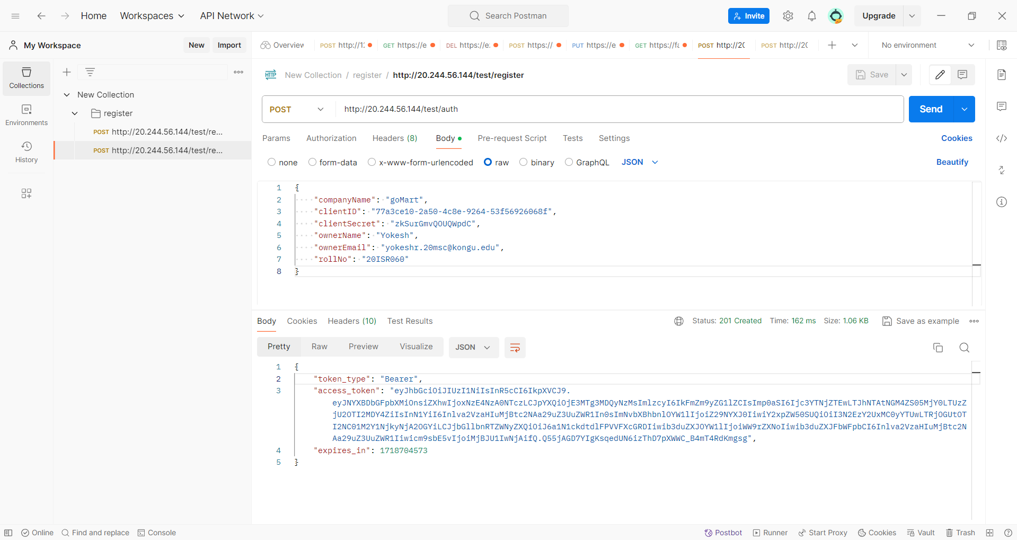

**Figure 1 – Registering Authorisation Token**

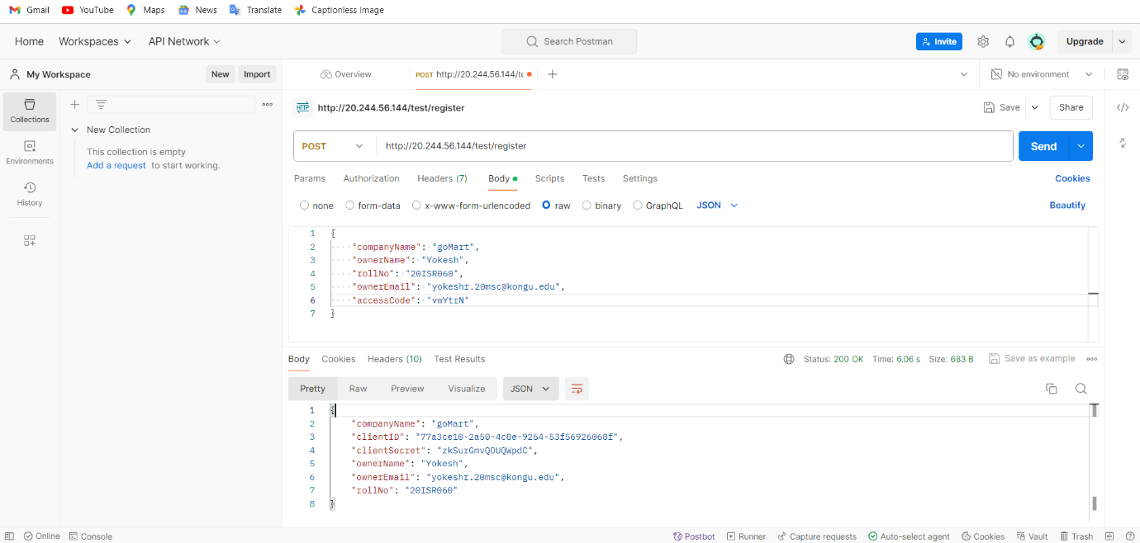

**Figure 2 – API Registration with Test Server**

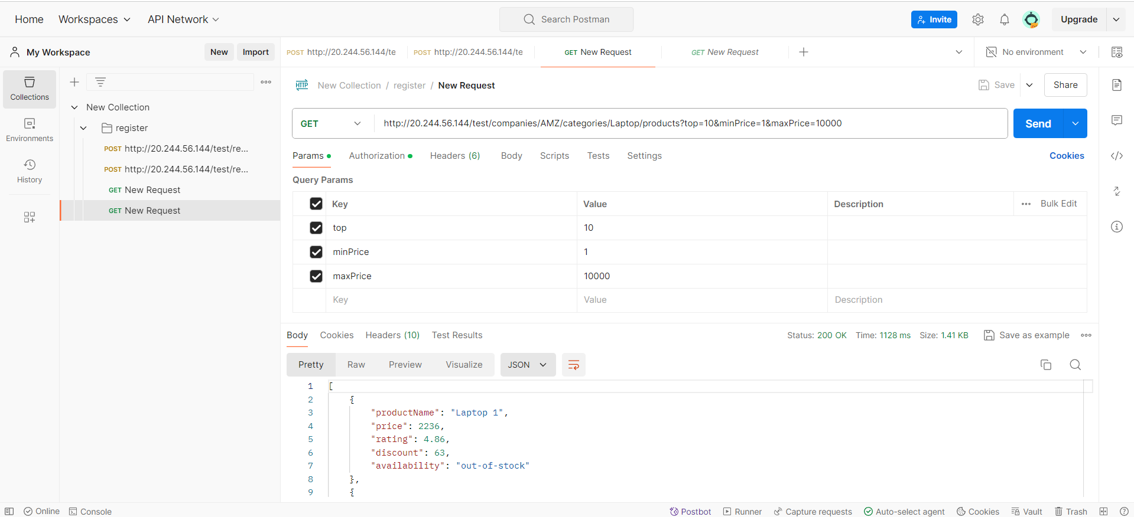

**Figure 3 - Testing E-commerce server APIs and displaying responses**

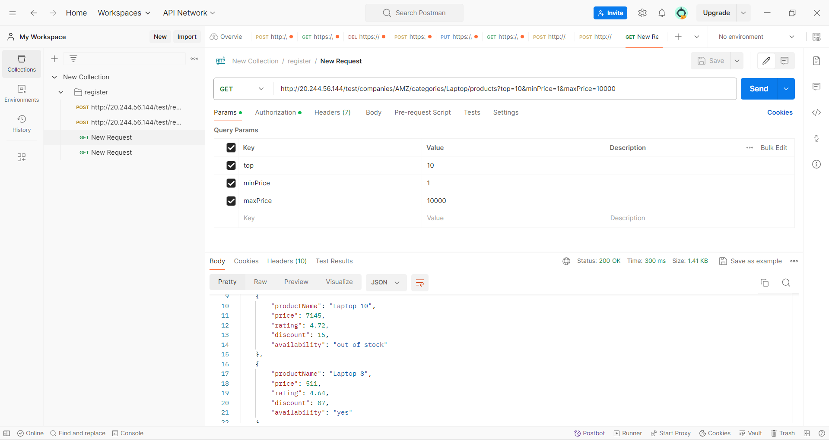

**Figure 4 - Testing E-commerce server APIs and displaying responses**

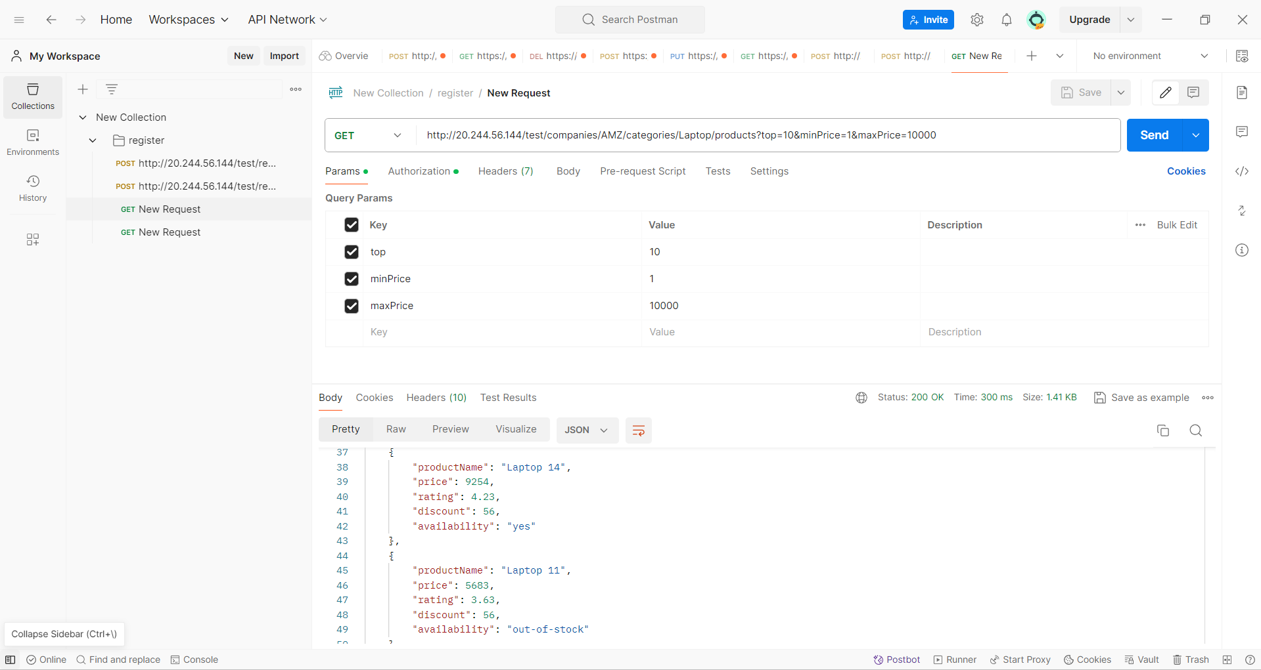

**Figure 5 – Testing E-commerce server APIs and displaying responses**

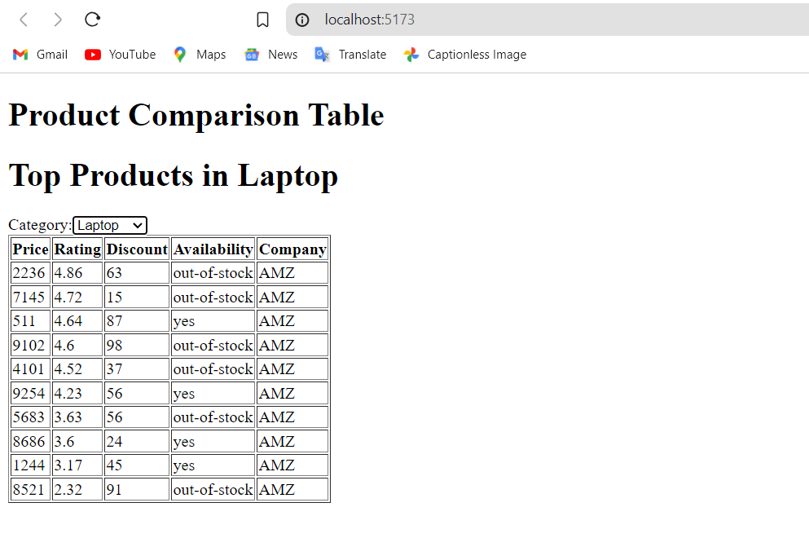

**Figure 6 – Displaying Top 10 Products In Browser in Laptop Category**

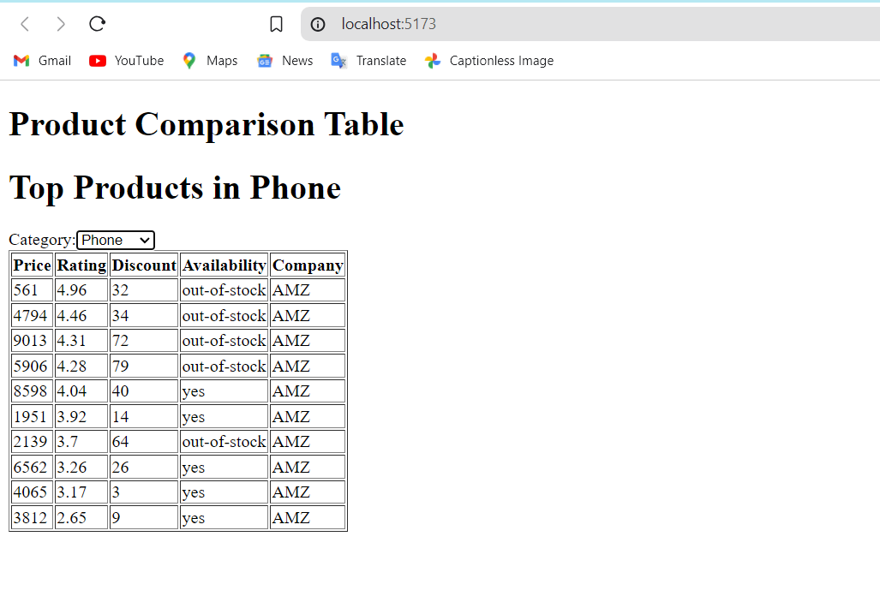

**Figure 7 – Displaying Top 10 Products In Browser in Phone Category**

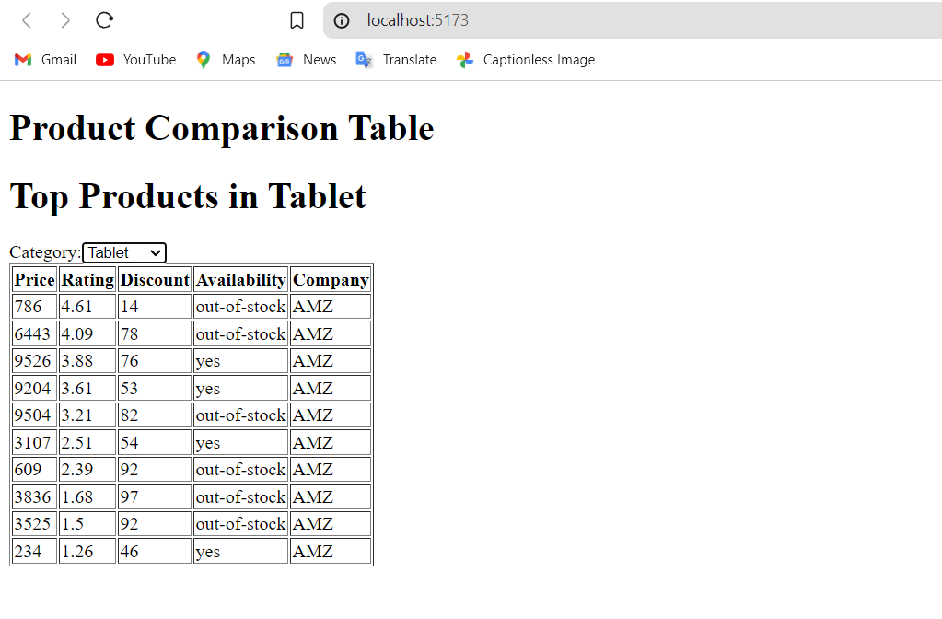

**Figure 8 – Displaying Top 10 Products In Browser in Tablet Category**

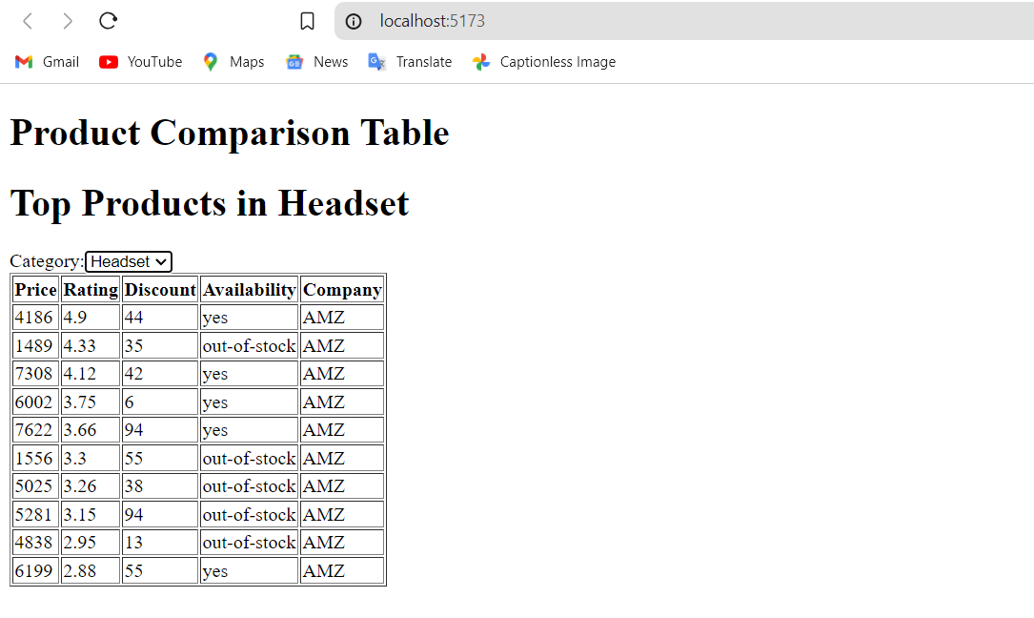

**Figure 9 – Displaying Top 10 Products In Browser in Handset Category**